**Ideation Phase**

**Define the Problem Statements**

|  |  |
| --- | --- |
| Date | 15 JUNE 2025 |
| Team ID | LTVIP2025TMID46308 |
| Project Name | DOC SPOT |
| Maximum Marks | 2 Marks |

**Customer Problem Statement Template:**

Crafting a well-defined **Customer Problem Statement** helps you focus on what truly matters to your customers. It enables your team to uncover meaningful insights and build solutions that resonate deeply with users—creating experiences they’ll love.

By clearly articulating the challenges your customers face, you can develop empathy, understand their needs, and see your product or service from their point of view. This shared understanding across your team ensures that your solutions are practical, relevant, and human-centered

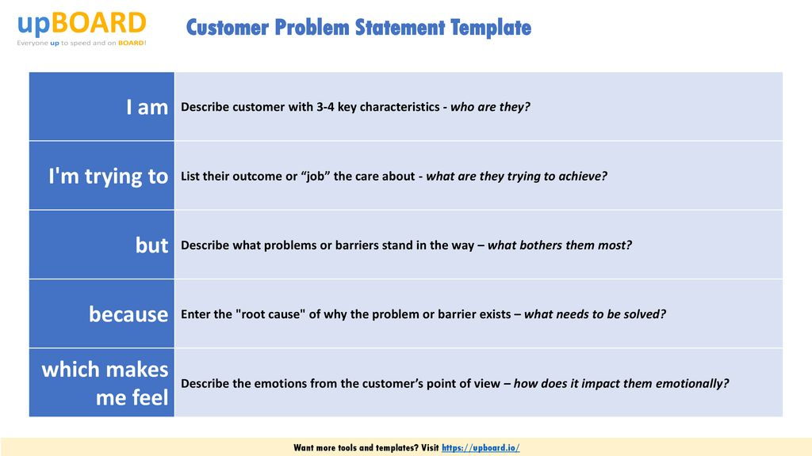

Reference: <https://miro.com/templates/customer-problem-statement/>

**Example:**

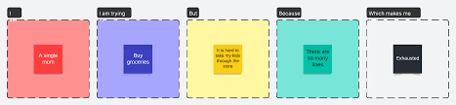

|  |  |  |  |  |  |
| --- | --- | --- | --- | --- | --- |
| **Problem Statement (PS)** | **I am (Customer)** | **I’m trying to** | **But** | **Because** | **Which makes me feel** |
| PS-1 | |  | | --- | |  |   a busy working professional | book a doctor’s appointment quickly and effortlessly | most clinics still rely on phone calls and don’t offer real-time availability | their booking systems are outdated, fragmented, or not user-friendly | frustrated, anxious, and concerned about delays in getting proper care |
| PS-2 | |  | | --- | |  |   a general physician managing a small clinic | streamline patient scheduling and minimize last-minute cancellations | I’m using outdated or generic tools that aren’t suited for healthcare needs | I lack the budget or technical expertise to implement complex systems | . overwhelmed, inefficient, and unable to focus on patient care |